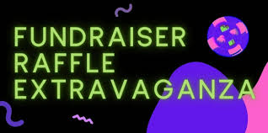
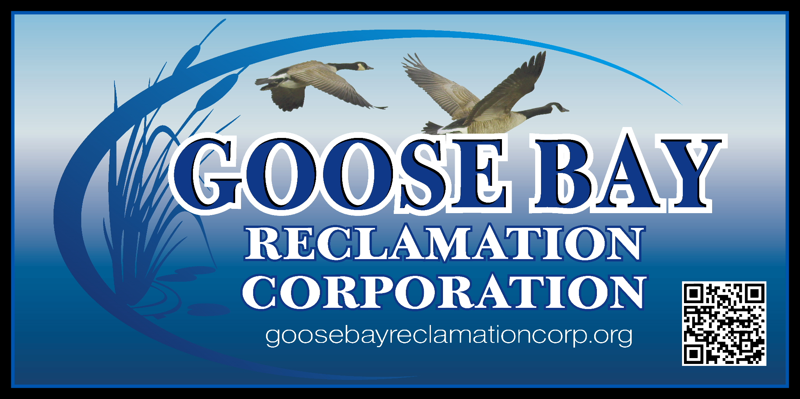

WELCOME TO OUR 2026 GBRC RAFFLE EXTRAVAGANZA!

We are raffling off some amazing prizes as a fundraiser! All you have to do is purchase the raffle tickets 1 for $5 or 3 for $10. Your tickets will then go in a random drawing for the prizes listed below. The drawings will be held at our Social/Annual Meeting on Saturday, August 22nd at the Kring Point State Park pavilion. The Social runs from 1:00-3:00 pm. Desserts and beverages will be provided.

The prizes are:
- an overnight stay at the Riveredge Resort
- 2 cans of Sherwin-Williams paint and painting kit ($225 value)
- The Clipper Inn $50 gift certificate
- Alex Bay sweatshirt donated by Bay View T's (3 to give away - $30 value each)
- decorative rubber floor mat donated by Cranberry Bogs Country Decor ($24 value)
- JK Roadhouse $25 gift certificate and sweatshirt ($50 value)
- Boldt Castle puzzle donated by The Ship Gift Shop ($20 value)
- Harbor Hotel $25 gift card
- 2 Uncle Sam's Boat Two Nation Boat Tour tickets donated by USBT ($59.50 value)

- a Goose Bay necklace donated by Treasure Island ($58 value)
- 3 Michael Ringer books donated by Michael Ringer Gallery ($80 value)
- Car wash basket donated by Swan Bay Resort ($78.50 value)
- Old Homestead Restaurant $50 gift certificate
- Jreck Subs Party Platter gift certificate donated by Alex Bay Jreck Subs ($55 value)
- The Gift Zone basket with wine glasses, picture frame and water bottle ($30 value)
- Rt. 37 Building Supply $50 gift card
- St. Lawrence Seaway chart shirt donated by Buoy's Boutique ($52 value)
- North Star Diner $25 gift certificate
- American Narrows beach blanket ($25 value)
- There may be additional prizes added, watch for updated list as we get closer to event.

Please complete and return the enclosed tickets by mail by August 7th. Tickets can also be dropped off to Debbie or turned in on the day of the Social/Annual Meeting. For more tickets or information, contact Debbie at (315) 482-5203 or goosebayreclamationcorp.org@gmail.com.
