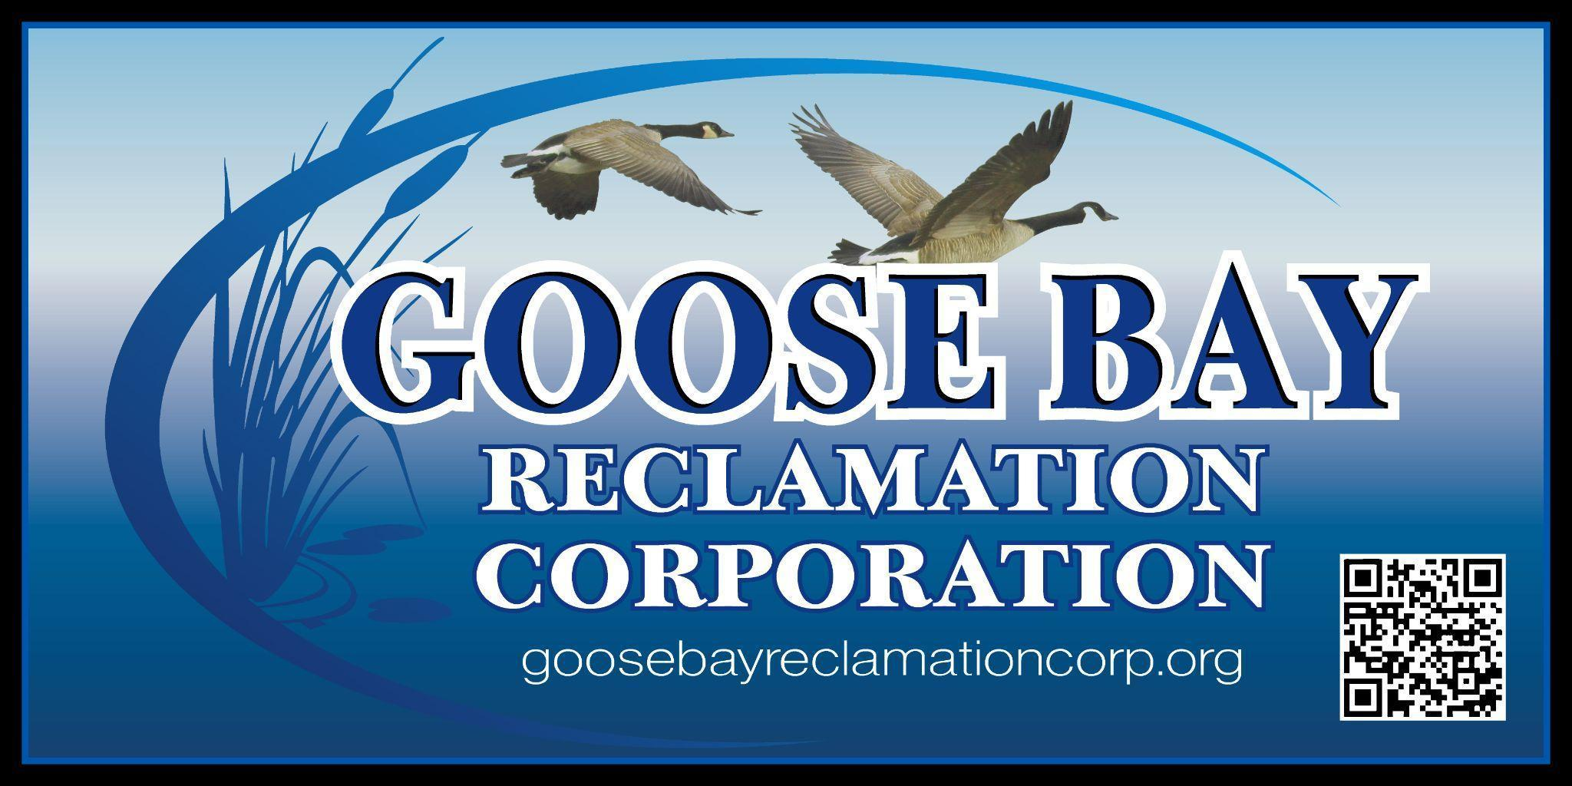

**Golf Tournament**

The **Goose Bay Reclamation Corporation** will be holding a golf tournament at the **LaFargeville Golf Club** on **July 19th, 2025** starting at 10:00AM to raise funds. We are offering local businesses an advertising opportunity by sponsoring one of the holes on the course. To accommodate as many interested parties as possible, we are accepting two sponsors per hole. **The cost of sponsorship is $100 and is tax deductible as GBRC is a non-profit organization.** As a sponsor, **your business sign** will be displayed at a hole on the course where it will be seen by all tournament participants and spectators.

Goose Bay has long been a hot spot for residents and visitors who enjoy boating, fishing, and water sports of all kinds. Funds raised will be used by GBRC to continue its work reducing and controlling the invasive Eurasian Milfoil weed that is threatening the ecosystem and navigation of beautiful Goose Bay. Through grants and past fundraising, GBRC was able to successfully treat a portion of the Bay with approval and guidance from the DEC. It’s well worth the effort to save it as such and we appreciate your support!

**Your sponsorship can help us save Goose Bay!**

To sponsor a hole for the Goose Bay Reclamation Corporation’s Golf tournament, complete the attached form and send it with a check for **$100** made payable to **Goose Bay Reclamation Corporation** to**:**

**Goose Bay Reclamation Corporation P.O. Box 111 Alexandria Bay, NY 13607**

**For questions, call Debbie at (315) 482-5203.**



Name:________________________________________________________

Business Name:_________________________________________________

Phone Number:_________________________________________________

************************************************************************

_____I would like to sponsor a hole for the Goose Bay Reclamation Corporation’s Golf Tournament. My check for $100 is enclosed.

_____I **have** a business sign for you to use

_____I **do not** have a business sign, but will share with you our electronic logo

(We will contact you to either pick up your sign or to discuss details of one we make for you.)

**********************************************************************

_____I am unable to sponsor a hole for the Goose Bay Reclamation Corporation’s Golf Tournament, but would like to support the GBRC’s efforts to save Goose Bay through the following donation of $_______

**********************************************************************

_____I am unable to sponsor a hole for the Goose Bay Reclamation Corporation’s Golf Tournament, but would like to support the GBRC’s efforts to save Goose Bay by donating the following item/service/gift certificate as a raffle item at the tournament: _________________________________________________